
Fallbrook High Athletics
Pursuing VICTORY with HONOR

Sports Offered with Coaches Contact Information

Girls Sports | Boys Sports
Basketball Samuel Harrison sharrison@fuhsd.net | Baseball Paul Martinez | pmartinez@fuhsd.net
Cross Country Shavonne D. shavonnedonoghue@fuhsd.net | Basketball Terron Sumpter | tsumpter@fuhsd.net
Field Hockey Melissa Palmer mpalmer@fuhsd.net | Cross Country Marco Arias | marias@fuhsd.net
Golf Neil Medlock nmedlock@fuhsd.net | Football John Hollcraft | jhollcraft@fuhsd.net
Gymnastics Viridiana Estrella viridiana.m.estrella@gmail.com | Golf Neil Medlock | nmedlock@fuhsd.net
Soccer Salvador Cabrera scabrera@fuhsd.net | Soccer Jorge Rojas | jrojas@fuhsd.net
Softball Lisa Stehle-Mtz lstehle@fuhsd.net | Swimming Scott Wiessner | swiessner@fuhsd.net
Swim/Diving Sean Redmond seanmary@aol.com | Tennis VACANT | VACANT
Tennis Susan Lenaway lenaways@gmail.com | Track Marco Arias | marias@fuhsd.net
Track Mike Crain mike@realtyincorporated.com | Volleyball Chip Patterson | chocchip44@gmail.com
Volleyball Madison McComas madisonnmccomas@gmail.com | Water Polo Scott Wiessner | sweissner@fuhsd.net
Water Polo Sean Redmond seanmary@aol.com | Wrestling Edgar Gomez | edgargomez80@gmail.com
Lacrosse VACANT VACANT | Lacrosse Ian McKesson | ianmckesson@hotmail.com

Competitiveness & Commitment

Athletic Office Contact Information

Patrick Walker, ATHLETIC DIRECTOR
pwalker@fuhsd.net
723-6300 EXT. 3601
Claudia Méndez, Athletic Secretary ext: 3610 cmendez@fuhsd.net
Sean Carbajal, Athletic Trainer ext 3608 mailto:scarbajal@fuhsd.net
Important Information for FHS Student-Athletes & Families

FHS sports teams are more competitive than youth recreational leagues and require a higher level of skill and commitment.
- Playing time is determined by the coach and is never guaranteed.
- Open communication between athletes and coaches is highly encouraged, especially regarding team issues, playing time, and absences.
- Full commitment to the selected sport is expected from both athletes and parents.
Please note that tournaments, practices, and games may take place during summer, Thanksgiving week, winter and spring breaks, and other holidays.
All athletes are required to attend team meetings, practices, games, and tournaments unless an illness or emergency arises. It is the athlete’s responsibility to communicate with coaching staff in advance if an absence is anticipated.
You may review previous year’s participation data under Athletic Information on our website.

Athletic Clearance Process
An athletic clearance is mandatory for all students trying out or participating in any sport.
- The Athletic Packet must be completed online at: athleticclearance.com
- A physical exam form may be picked up at "Physical Night" or in the Athletic Director’s Office afterward. Important Reminders:
- You must complete clearance for each sport individually.
- Your information will be saved, making it easier to update for future sports or school years.
- Sports clearance must be completed each school year, even if you participated the year before.
- Students in year-round sports classes must be cleared before the start of the 1st trimester. After completing the online process, please bring the following to the Athletic Director’s Office:
- A copy of your medical insurance card
- The physical form signed by the doctor (only if you could not upload it to Home Campus or email it)

If you do not have internet access, assistance is available by appointment in the Athletic Office.

Notice of Student Nondiscrimination
Fallbrook Union High School District is committed to equal opportunity for all individuals in education. District programs and activities shall be free from discrimination based on the following actual or perceived characteristics:
- Sex, sexual orientation, gender, gender identity, gender expression
- Ethnic group identification, race, ancestry, national origin, religion, color
- Mental or physical disability, nationality, age, creed, marital status
- Association with a person or group with one or more of these characteristics
- A student’s actual or perceived potential parental, family, or marital status
Violations of this policy may result in disciplinary action, up to and including expulsion for students or dismissal for employees, in accordance with applicable laws and agreements.

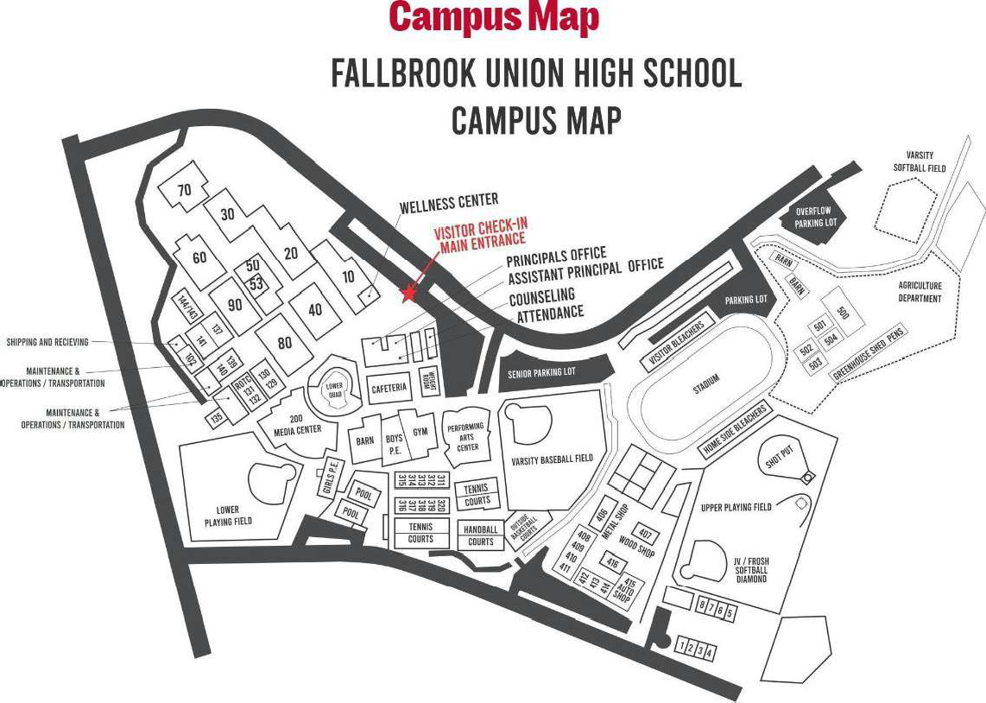

Fall Sports – Aug–Nov Winter Sports – Nov-Feb
Sport | Home Contest  Times | Competition Location Sport | Home Contest  Times | Competition  Location
 |  |  |  | JV/V-Stadium/F-Ivy
Cross Country | V/JV/F 3:40 | Stadium Boys Soccer | F/JV-3:40/V-5:00 | Field
 |  |  |  | JV/V-Stadium/F-Ivy
Field Hockey | V-4:00/JV-5:30 | Stadium Girls Soccer | F/JV-3:40/V-5:00 | Field
 |  |  | JV-4:30 or5:30/V-
Football | JV-4:30/V-7:00 | Stadium Boys Basketball | 7:00 | Gym
 | F-5:00 | Stadium | F-Sat 9:00-4:30
 |  |  | JV-4:30 or5:30/V-
Girls Golf | V/JV-3:40 | Fallbrook Golf Course Girls Basketball | 7:00 | Gym
Girls Tennis | 3:40 | Varsity-Fallbrook Tennis Club | F-Sat 9:00-4:30
 | 3:40 | JV-FHS Tennis Courts Wrestling | F/JV-5:30/V-7:00 | The Barn
 |  |  | JV-3:40/V-
Girls Volleyball | F/JV-4:00/V-5:30 | East Gym Girls Water Polo | 4:30/N:5:30 | Pool
Boys Water Polo | JV-3:30/V-4:30/N:5:30 | Pool
 |  | Spring Sports – Feb-May
Sport | Home Contest Times | Competition Location Sport | Home Contest Times | Competition Location
Baseball | JV/V-3:30 | Varsity Baseball Field Swimming/Diving | JV/V-3:00 | Pool
 | F/3:30 | Lower Field Boys Tennis | V-3:30 | FHS Tennis Courts
Boys Golf | V-3:30 | Pala Mesa | JV-3:30 | FHS Tennis Courts
 | JV-4:30 | Fallbrook Golf Club Track and Field | JV/V-3:30 | Stadium/Ivy Field
Gymnastics | JV/V-3:30 | West Gym Boys Volleyball | JV-4:30/V-5:30 | Gym
Softball | V-3:30 | Varsity Softball Field Boys Lacrosse | JV-5:30/V-7:00 | Stadium
 | JV/F-5:30 | Ivy Field Girls Lacrosse | JV-5:30/V-7:00 | Stadium

** Dates of Season and Days of Play are determined by CIF. Days of Play CIF Link CIF Master Calendar – Season Dates

